VISVESVARAYA TECHNOLOGICAL UNIVERSITY

JNANASANGAMA, BELAGAVI-590014


AMini-ProjectReporton

“THE WEATHER PREDICTION USING MACHINE LEARNING”
Submitted for partial fulfillment of requirement for the award of Degree of

Bachelor of Engineering in
Department of CSE(Artificial Intelligence & Machine Learning)
Submitted by
MANOJ C S (1RL22CI029)
MUTHARAJU S R (1RL22CI031)
RAGHAVENDRA (1RL22CI044)
of
V Semester
Under the guidance of

Mrs.ANUPRIYA A G
Associate Professor, CSE(AI&ML)



Department of CSE(Artificial Intelligence & Machine Learning)
R.L.JALAPPA INSTITUTE OF TECHNOLOGY
(Approved by AICTE,New Delhi Affiliated VTU, Belagavi & Accredited by NAAC -“A” grade)

Doddaballapur , Bangalore Rural District-561203
2024-25

Sri Devaraj Urs Educational Trust(R.)
R.L.JALAPPA INSTITUTE OF TECHNOLOGY
(Approved by AICTE, New Delhi Affiliated VTU, Belagavi & Accredited by NAAC- “A” grade)
Kodigehalli, Doddaballapur-561 203

Department of CSE(Artificial Intelligence & Machine Learning)



CERTIFICATE
This is to certify that the Mini Project work entitled “THE WEATHER PREDICTION USING MACHINE LEARNING” carried outby MANOJ C S(1RL22CI029), MUTHARAJU S R(1RL22CI031), RAGHAVENDRA (1RL22CI044) bonafide students of R. L. Jalappa Institute of Technology has been completed in partial fulfillment of the requirements for the award of the Bachelor of Engineering in Computer Science and Engineering (Artificial Intelligence & Machine Learning) of Visvesvaraya Technological University, Belagavi, during the academic year 2024-25.

It is certified that all corrections and suggestions indicated for internal assessment have been duly in corporated into the final report which has been deposited in the Department Library . The Mini Project report has been approved as it meets the academic requirements prescribed for the Mini Project work for the said degree.

Mrs.ANUPRIYA AG  Associate Professor  Dept of CSE(AI&ML) | Dr. Manjunatha B.N HoD&AssociateProfessor  Dept.ofCSE(AI&ML) | Dr.PVijayakarthik Principal RLJIT

Sri Devaraj Urs Educational Trust(R.)
R.L.JALAPPA INSTITUTE OF TECHNOLOGY
(Approved by AICTE, New Delhi Affiliated VTU, Belagavi & Accredited by NAAC “A” grade)
Kodigehalli, Doddaballapur-561203

Department of CSE(Artificial Intelligence & Machine Learning)

DECLARATION

We here by declare that the work, which is being presented in the project report entitled “THE WEATHER PREDICTION USING MACHINE LEARNING” in partial fulfillment for the award of Degree of Bachelor of Engineering in CSE(Artificial Intelligence & Machine Learning), is are cord of our own investigations carried under the guidanceof Guide Mrs.ANUPRIYA A G Associate Professor DEPT.OF CSE(AI&ML), RL JALAPPA INSTITUTE OF TECHNOLOGY, DODDABALLAPUR , BENGALURU RURAL.
We have not submitted the matter presented in this report anywhere for the award of any other Degree.

MANOJ C S 1RL22CI029
MUTHARAJU S R 1RL22CI031
RAGHAVENDRA 1RL22CI044

Weather prediction, also known as weather forecasting, is a critical process that entails using various scientific principles and technologies to anticipate atmospheric conditions at a future time for a specific location. The procedure relies on data collection from multiple sources, including satellites, weather stations, ocean buoys, aircraft, and ground-based observations. This data provides essential information on temperature, humidity, wind speed and direction, atmospheric pressure, and other meteorological variables.

Central to weather prediction are numerical weather prediction (NWP) models. These models use mathematical equations to simulate the atmosphere's behavior based on the initial conditions derived from observational data. The Earth's atmosphere is divided into a grid, and each grid point's future state is computed over time. Due to the atmosphere's chaotic nature, small errors in initial conditions can lead to significant discrepancies in forecasts, known as the "butterfly effect." Thus, ensemble forecasting, which runs multiple simulations with slightly varying initial conditions, is often employed to estimate uncertainty and improve forecast reliability.

Besides NWP models, statistical methods and machine learning techniques are increasingly integrated into weather prediction. These approaches analyze historical data to identify patterns and correlations that can enhance forecast accuracy. Machine learning algorithms, for instance, can improve short-term predictions of precipitation or severe weather events by recognizing complex patterns that traditional methods might overlook.

However, the complexity of the atmosphere poses ongoing challenges. Accurate long-term forecasts remain elusive due to the sensitivity of atmospheric systems to initial conditions and the interplay of various climatic factors. Additionally, localized weather phenomena, such as thunderstorms or tornadoes, are particularly difficult to predict with precision.

Advancements in technology and computational power continue to drive improvements in weather forecasting. Enhanced satellite imagery, high-resolution models, and real-time data assimilation are among the innovations making predictions more accurate. The rise of supercomputing allows for more detailed simulations, while advancements in remote sensing provide better observational data.

The importance of accurate weather prediction cannot be overstated. It is crucial for various sectors, including agriculture, where it aids in planning and protecting crops; transportation, by enhancing the safety and efficiency of air, sea, and land travel; and disaster management, by providing early warnings for severe weather events and helping mitigate their impact. Additionally, everyday life benefits significant.

WithGreatpride we wouldlike to convey our gratitude and appreciation to our college “R.L. Jalappa Institute of Technology” forgiving us there quired platform for efulfilment of the Mini project on THE WEATHER PREDICTION USING MACHINE LEARNING as per the V.T.U requirements, for the Fifth semester.
We express my sincere thanks to Dr.P VijayaKarthik, Principal of R.L.Jalappa Institute of Technology, Doddaballapura for providing me with excellent infrastructure to complete the Mini project.
We express wholehearted gratitude to Dr. Manjunatha B N who is the respectable Associate Professor, HOD of CSE (AI & ML) Department. We wish to acknowledge his help in making my task easy by providing me with his valuable help and encouragement.
It is our pleasure to thank our guide Mrs Anupriya AG Professor of CSE (AI & ML) Department, RLJIT for their guidance, encouragement and valuable suggestion from the beginning of the Mini project work till the completion without which this Mini project work would not have been accomplished. We are greatly indebted to them.
And last but not the least, we would be very pleased to express our heart full thanks to the Teaching and Non-teaching staff of the Department of Computer Science and Engineering (AI & ML), RLJIT for their motivation and support.
We also thank all those who extended their support and co-operation while bringing out this Mini project.

RAGHAVENDRA 1RL22CI044
MANOJ C.S 1RL22CI029
MUTHARAJU S.R 1RL22CI031

TableofContents

CHAPTERNO. | TITLE | PAGENO.
 | ABSTRACT | i
 | ACKNOWLEDGMENT | ii
1 | INTRODUCTION | 9-10
 | 1.1Introduction | 9.1
 | 1.2PurposeandMissionofHandgesture recognition | 9.2
 | 1.3ImageProcessing | 9.2-3
 | 1.4Machine Learning | 9.3
 | 1.5ProblemStatement | 9.44
 | 1.6ProjectObjectives | 10
 | 1.7SystemOverview | 10.1
 | 1.8 Motivation | 10.2
 | 1.9OverviewofReport | 10.3
2 | LITERATURE SURVEY | 11-22
 | 2.1ResearchonHandGestureRecognition Techniques | 11.1
 | 2.2ComputerVisionandDigitalImage Processing | 11.1.2
 | 2.3OpenCVinImage Processing | 11.2
 | 2.4Featureextractionand selection | 11.3
 | 2.5Dataacquisitionandpreprocessing | 11.4
3 | REQUIREMENT ANALYSIS | 24-37
 | 3.1GeneralDescription | 24.1
 | 3.2Functional Requirements | 25
 | 3.3Non-functionalRequirements | 29
 | 3.4ExternalInterface Requirements | 34
4 | SYSTEM DESIGN | 38-43
 | 4.1 Flow Chart | 38.4
 | 4.2Convolution Neural Networks | 41
 | 4.3Gesture Interpretation | 42

5 | IMPLEMENTATION | 44-49
 | 5.1 Volume Control(Case1) | 44.1
 | 5.2 DinoGameControl(Case2) | 45
 | 5.3 PowerPointControl(Case3) | 46
 | 5.4 Python | 47
 | 5.4 Key Libraries and Technologies | 48
 | 5.5 Summary of Implementation | 49
6 | RESULT AND DISCUSSION | 50-57
 | 6.1 Experiment Setup | 52
 | 6.2 Source Code | 55
 | 6.3 Results | 56
7 | CONCLUSION AND DISCUSSION | 58-60
 | 7.1 Applications | 58.2
 | 7.2 Advantages | 59
 | 7.3 Conclusion | 60
8 | FUTURESCOPE | 61
 | APPENDIX | 62
 | REFERENCES | 63

List of Figures

Sl.  No. | Figure Name | Caption | Page No.
1 | Source code output | Weather prediction using Machine Learning outputs | 50

Chapter 1

INTRODUCTION

Introduction

Weather prediction, also known as weather forecasting, is the scientific practice of determining future atmospheric conditions at a specific location over a certain period. This essential process affects various aspects of daily life, from individual decision-making to large-scale planning in industries like agriculture, aviation, and disaster management. Understanding the intricacies of weather prediction requires delving into its history, methodologies, technological advancements, and the significant role it plays in modern society.

The origins of weather prediction can be traced back to ancient civilizations, where people relied on natural signs and folklore to anticipate weather changes. Observations of animal behavior, cloud formations, and wind patterns were among the earliest methods used to predict weather. However, these rudimentary techniques offered limited accuracy and reliability. The field began to evolve significantly in the 19th century with the advent of meteorology as a formal scientific discipline. Pioneers like Francis Beaufort and Robert FitzRoy made substantial contributions by developing systematic weather observation methods and issuing early weather forecasts for maritime navigation.

Modern weather prediction is a sophisticated and dynamic process that combines data collection,analysis, and computer modeling. The foundation of accurate weather forecasting lies in the continuous collection of atmospheric data from various sources. Weather stations, satellites, radars, and buoysplay crucial roles in this data-gathering process. Weather stations, equipped with instruments like thermometers, barometers, and anemometers, measure parameters such as temperature, atmospheric pressure, and wind speed. Satellites orbiting the Earth provide valuable information on cloud cover, sea surface temperatures, and atmospheric moisture content. Radars are essential for detecting precipitation and tracking severe weather phenomena like thunderstorms and hurricanes.

Once collected, this vast amount of data is fed into sophisticated computer models known as numerical weather prediction (NWP) models. These models simulate the behavior of the atmosphere based on physical laws and equations governing fluid dynamics, thermodynamics, and radiation. NWP models divide the atmosphere into a three-dimensional grid, with each cell representing a specific volume of air. By solving complex mathematical equations for each grid cell, these models generate forecasts for temperature, humidity, wind, and precipitation over a designated forecast period.

Despite the advances in data collection and modeling, weather prediction remains a challenging task due to the chaotic nature of the atmosphere. Small changes in initial conditions can lead to significant variations in weather outcomes, a concept known as the butterfly effect. To mitigate this uncertainty, meteorologists use ensemble forecasting, which involves running multiple simulations with slightly different initial conditions. The resulting ensemble of forecasts provides a range of possible outcomes, allowing forecasters to assess the probability of various weather scenarios.

One of the most significant advancements in weather prediction has been the development of high-performance computing (HPC). The ability to process vast amounts of data and perform intricate calculations quickly is essential for producing timely and accurate forecasts. Supercomputers, with their immense computational power, enable meteorologists to run complex NWP models and generate forecasts within a matter of hours. The integration of artificial intelligence (AI) and machine learning (ML) techniques has further enhanced the accuracy of weather predictions. These technologies can analyze historical weather data, identify patterns, and improve model performance by learning from past forecast errors.

Weather prediction is not only about providing information on daily weather conditions but also about anticipating extreme weather events and mitigating their impacts. Early warning systems for hurricanes, tornadoes, floods, and heatwaves have saved countless lives and minimized economic losses. For instance, the National Hurricane Center in the United States uses advanced forecasting models to predict the path and intensity of hurricanes, allowing authorities to issue timely evacuation orders and preparedness measures. Similarly, weather prediction plays a vital role in agriculture, enabling farmers to make informed decisions about planting, irrigation, and harvesting.

The aviation industry relies heavily on accurate weather forecasts for flight planning and safety. Pilots and air traffic controllers use weather information to navigate around storms, turbulence, and other hazardous conditions. In the maritime sector, weather prediction helps in route planning and ensuring the safety of ships at sea. Additionally, the energy sector benefits from weather forecasts for optimizing the production and distribution of renewable energy sources like wind and solar power.

While weather prediction has made remarkable strides, it is not without its limitations. Forecast accuracy diminishes with increasing lead time, meaning that short-term forecasts are generally more reliable than long-term predictions. The inherent variability of the atmosphere and the limitations of current models contribute to this decline in accuracy. Furthermore, certain weather phenomena, such as thunderstorms and localized heavy rainfall, are particularly challenging to predict due to their small scale and rapid development.

The future of weather prediction holds promising possibilities with ongoing research and technological advancements. Scientists are continually refining NWP models, incorporating more accurate representations of physical processes and improving data assimilation techniques. The use of high-resolution models, which provide finer spatial and temporal details, is becoming increasingly common. Enhanced satellite technology and the deployment of more sophisticated weather observation instruments will further improve data quality and coverage. Moreover, the integration of crowd-sourced weather data from smartphones and other personal devices is emerging as a valuable resource for real-time weather monitoring.

In conclusion, weather prediction is a complex and evolving science that plays a vital role in modern society. From its humble beginnings in ancient observations to the cutting-edge technology of today, weather forecasting has come a long way. The continuous advancements in data collection, computer modeling, and computational power have significantly improved the accuracy and reliability of weather predictions. As research and technology continue to progress, the ability to forecast weather with greater precision and lead time will undoubtedly enhance our preparedness and resilience in the face of nature's ever-changing forces.

Chapter 2

LITERATURE SURVEY

A literature survey is a comprehensive overview of all the knowledge available on a specific topic up to the current date. It provides a solid foundation for research by identifying gaps, inconsistencies, and areas that require further investigation. The survey synthesizes existing studies, theories, and methodologies, presenting them in a coherent manner. It helps researchers understand the evolution of ideas and the current state of research. Through a literature survey, scholars can justify their research questions, propose new frameworks, and align their work with established research trends. Overall, it is an essential step in the research process, ensuring academic rigor and contributing to the body of knowledge.
Sr  No | Title of Paper | Conference/Journal/Year | Author | Conclusion
1 | Weather Prediction with Machine Learning | International Journal of Innovative Science and Research Technology (IJISRT) September 2024 | Dr. M. M Raghuwanshi,  Yogesh Katre, Ayushi Sahu, Disha Sharma | "Enhanced prediction accuracy."
2 | Ensemble Machine Learning based Weather Prediction System | International Journal of Innovative Science and Research Technology (IJISRT) 2023 | Vijayaganth V, Monicaa Jayasri PK, Narmadha S, Pavithra Devi S | "Improved forecast accuracy."
3 | Weather Forecasting Model using Artificial Neural Network | Procedia Technology (2012) | Kumar Abhisheka, M.P.Singha, Saswata Ghoshb, Abhishek Anand | "Enhanced forecast reliability."

Table2.Literature Survey

Dr. M. M Raghuwanshi, Yogesh Katre, Ayushi Sahu, Disha Sharma, Ankush Udapure, and Chaitanya Lonarkar proposed a machine-learning model for weather prediction in their paper titled "Weather Prediction with Machine Learning". Published in the International Journal of Innovative Science and Research Technology (IJISRT) in September 2024, their research focuses on using historical weather data to train a machine-learning model that can predict weather conditions with greater accuracy than traditional models. The model leverages artificial neural networks (ANNs) to capture complex patterns in atmospheric data, improving forecast reliability
In the paper "Weather Prediction with Machine Learning", Dr. M. M Raghuwanshi, Yogesh Katre, Ayushi Sahu, Disha Sharma, Ankush Udapure, and Chaitanya Lonarkar present an innovative approach to weather forecasting using machine learning techniques. Their research addresses the limitations of traditional weather prediction models, which often struggle to capture the complex .

Support Vector Machines and k-Nearest Neighbors
were among the first machine learning techniques applied to hand gesture recognition. These methods typically involved extracting feature vectors from images using techniques such as HOG (Histogram of Oriented Gradients) or SIFT (Scale-Invariant Feature Transform) and then classifying them with or. These methods showed promising results, particularly in gesture recognition tasks where the hand's motion was relatively constrained, such as in static sign language gestures. However, their performance deteriorated in more complex and dynamic environments. Convolutional Neural Networks are widely used for static gesture recognition, where images of the hand or gesture are fed into a which automatically learns discriminative features for classification. -based models, such as LeNet, AlexNet, and VGG, have been applied to recognize static hand gestures. These networks excel at automatically learning features like edges, shapes, and textures from images, eliminating the need for manual feature extraction. However, are more effective when the hand is in a fixed position, making them less suitable for recognizing dynamic gestures where the hand is in motion
One notable deep learning-based architecture is , which works directly on video frames, capturing both spatial and temporal features of hand gestures. By processing a sequence of frames as a 3D volume (instead of individual 2D frames), can capture motion information, making them effective for dynamic gesture recognition. This method is particularly useful in applications like sign language recognition, where understanding both the shape and movement of gestures is critical

and Digital Image Processing are closely related fields that play a crucial role in how machines perceive, interpret, and process visual information, enabling them to perform tasks that typically require human vision. These tasks range from image enhancement and object detection to scene understanding and face recognition, with applications spanning across industries such as healthcare, automotive, entertainment, robotics, and security. Digital Image Processing is the process of manipulating digital images to improve their quality or extract useful information. It encompasses a range of techniques aimed at enhancing, analyzing, or transforming an image to make it more suitable for specific tasks. For example, image enhancement techniques, like contrast adjustment and histogram equalization, improve the clarity of images, making them more visually appealing or more suitable for analysis. Filtering methods such as Gaussian blur or median filtering are used to remove noise and smooth out images, ensuring that the details are clear and the results are reliable. Another key aspect of is edge detection, where algorithms like the edge detector are used to identify boundaries within an image, which is vital for object recognition and scene segmentation. Image segmentation, another crucial DIP task, divides an image into meaningful regions based on pixel characteristics, allowing for the identification of different objects or areas of interest. Morphological operations such as dilation and erosion are applied to refine the image and enhance or suppress certain structures, improving the overall image quality.

The paper titled "Ensemble Machine Learning based Weather Prediction System"by Vijayaganth V, Monicaa Jayasri PK, Narmadha S, and Pavithra Devi S, published in the 2023 International Conference on Communication, Security and Artificial Intelligence (ICCSAI), presents a novel approach to weather forecasting using ensemble machine learning techniques.

Traditional weather forecasting methods often struggle to accurately predict weather conditions due to the complex and dynamic nature of atmospheric data. Machine learning has emerged as a promising tool to address these challenges, and ensemble methods, in particular, offer a robust solution by combining multiple machine learning models to improve predictive accuracy and reduce errors.

The authors employed various machine learning algorithms, including Random Forest, Gradient Boosting, and Neural Networks, to create an ensemble model. Each algorithm was trained on historical weather data to capture different aspects of atmospheric conditions. The ensemble model leverages the strengths of each individual algorithm, thereby improving overall prediction accuracy. The training data included parameters such as temperature, humidity, wind speed, and precipitation, which were preprocessed to ensure quality and consistency.

The ensemble model demonstrated superior performance compared to individual machine learning models. The authors evaluated the model using several metrics, including Mean Absolute Error (MAE) and Root Mean Square Error (RMSE), and found that the ensemble model significantly reduced prediction errors. This improvement is attributed to the model's ability to capture diverse patterns in the data, thanks to the combination of multiple algorithms.

The enhanced accuracy of the ensemble machine learning model has several practical applications. In agriculture, accurate weather forecasts can help farmers make informed decisions about irrigation, planting, and harvesting. In disaster management, reliable weather predictions can aid in early warning systems and preparedness planning, potentially saving lives and resources. Urban planning can also benefit from accurate weather forecasts, helping to design resilient infrastructure and manage resources effectively.

The study concludes that ensemble machine learning techniques hold great promise for improving weather prediction accuracy. The authors suggest that future research could explore the integration of more diverse datasets, including satellite imagery and real-time sensor data, to further enhance the model's predictive capabilities. Additionally, advanced machine learning techniques, such as deep learning, could be incorporated to capture even more complex patterns in atmospheric data.

This detailed examination of their work highlights the potential of ensemble machine learning in transforming weather forecasting, providing more accurate and reliable predictions that can benefit various sectors and improve decision-making processes.

The study concludes that Artificial Neural Networks offer a promising approach to weather forecasting, providing more reliable and accurate predictions. The authors suggest that future research could explore the integration of more diverse datasets and advanced machine learning techniques to further enhance the model's predictive capabilities

applications like sign language recognition, where understanding both the shape and movement of gestures is critical.
Generative Adversarial Networks (GANs) have also been explored for hand gesture recognition, particularlyin data augmentation tasks. GANscan generaterealisticsynthetichand gestureimages orvideostoaugmenttrainingdatasets,whichcanhelpimprovemodelgeneralizationandrobustness, especially in cases where labeled training data is limited.

The paper titled "Weather Forecasting Model using Artificial Neural Network"by Kumar Abhisheka, M.P.Singha, Saswata Ghoshb, and Abhishek Anand was published in the Procedia Technology journal in 2012.

Their research focuses on developing a weather forecasting model using Artificial Neural Networks (ANNs). Traditional weather forecasting methods often rely on linear relationships between input data and target predictions, which can be inadequate due to the nonlinear and complex nature of weather data. The authors propose using ANNs to capture these nonlinear relationships and improve prediction accuracy.

The authors collected historical weather data, including parameters such as temperature, humidity, wind speed, and precipitation. This data was used to train the ANN model. They experimented with different network architectures, including various numbers of hidden layers and neurons, to optimize the model's performance. The model was evaluated using metrics such as Mean Squared Error (MSE) and Root Mean Square Error (RMSE) to assess its accuracy.

The ANN-based model demonstrated superior performance compared to traditional forecasting methods. The authors found that the ANN model could effectively capture the complex patterns in weather data, leading to more accurate predictions. The model's ability to adapt to nonlinear trends in the data made it a robust tool for weather forecasting.

Accurate weather forecasting is crucial for various sectors, including agriculture, disaster management, and urban planning. The improved accuracy of the ANN model can help farmers make informed decisions about irrigation and planting, aid in early warning systems for natural disasters, and assist in designing resilient infrastructure..
systems often require large, diverse datasets to train models that work well across different users, with variations in hand shape, size, and skin tone. Research in transfer learning and domain adaptationisexploringwaystoimprovethegeneralizationofmodelstonewuserswithouttheneed for extensive retraining.
Furthermore, multi-hand and complex gestures, such as simultaneous handgestures orinteractions with objects, present a challenging problem that requires advanced techniques capable of handling multiple hands and complex interactions.
Hand gesture recognition has evolved from traditional image processing techniques to advanced machine learning and deep learning approaches. While early methods focused on handcrafted features and simple algorithms, modern systems use sophisticated neural networks that can learn complex representations directly from raw data. Deep learning models, particularly CNNs, RNNs, and 3D-CNNs, have demonstrated exceptional performance in both static and dynamic gesture recognition. The integration of multiple sensors and hybrid approaches further enhances accuracy and robustness. However, challenges like real-time processing, generalization, and handling complex gestures remain areas for further research and development, promising exciting advances in the field of hand gesture recognition.

Effective feature extraction and selection are crucial for hand gesture recognition systems, as they reducecomputationalcomplexity,improvemodelperformance,andensurethatthesystemremains robust to variations in lighting, background, and user-specific factors. By focusing on the most relevantfeatures , these techniques enable more accurate ,efficient ,and real-time gesture recognition, making them indispensable in applications like human-computer interaction, sign language recognition, and virtual reality.

Data acquisition and preprocessing are critical stages in developing an efficient hand gesture recognition system. These stages ensure that the rawinput data, typicallycaptured through various sensors, is transformed into a format suitable for accurate analysis and model training. Data acquisition focuses on collecting diverse, high-quality data that covers various hand gestures and user variations, while preprocessing refines this data by enhancing quality, reducing noise, and extracting relevant features for the recognition model. Data acquisition involves capturing images or video frames of hand gestures using different sensors. Commonly used sensors include RGB cameras, depth sensors, and inertial sensors.
The paper titled "Weather Forecasting Model using Artificial Neural Network" by Kumar Abhisheka, M.P.Singha, Saswata Ghoshb, and Abhishek Anand was published in the Procedia Technology journal in 2012.
Their research focuses on developing a weather forecasting model using Artificial Neural Networks (ANNs). Traditional weather forecasting methods often rely on linear relationships between input data and target predictions, which can be inadequate due to the nonlinear and complex nature of weather data. The authors propose using ANNs to capture these nonlinear relationships and improve prediction accuracy.
The authors collected historical weather data, including parameters such as temperature, humidity, wind speed, and precipitation. This data was used to train the ANN model. They experimented with different network architectures, including various numbers of hidden layers and neurons, to optimize the model's performance. The model was evaluated using metrics such as Mean Squared Error (MSE) and Root Mean Square Error (RMSE) to assess its accuracy.
The ANN-based model demonstrated superior performance compared to traditional forecasting methods. The authors found that the ANN model could effectively capture the complex patterns in weather data, leading to more accurate predictions. The model's ability to adapt to nonlinear trends in the data made it a robust tool for weather forecasting.

Accurate weather forecasting is crucial for various sectors, including agriculture, disaster management, and urban planning. The improved accuracy of the ANN model can help farmers make informed decisions about irrigation and planting, aid in early warning systems for natural disasters, and assist in designing resilient infrastructure.
The study concludes that Artificial Neural Networks offer a promising approach to weather forecasting, providing more reliable and accurate predictions. The authors suggest that future research could explore the integration of more diverse datasets and advanced machine learning techniques to further enhance the model's predictive capabilities.
The paper titled "Weather Forecasting Model using Artificial Neural Network" by Kumar Abhisheka, M.P.Singha, Saswata Ghoshb, and Abhishek Anand, published in the Procedia Technology journal in 2012, explores the application of Artificial Neural Networks (ANNs) in weather forecasting. Given the nonlinear and intricate nature of weather data, traditional linear models often fall short in accurately predicting weather conditions. The authors' research aims to address these limitations by leveraging the capabilities of ANNs to capture complex patterns and improve forecast accuracy.
The authors collected extensive historical weather data, including key parameters such as temperature, humidity, wind speed, and precipitation. This data, sourced from meteorological stations and other reliable sources, was meticulously preprocessed to ensure quality and consistency. The preprocessing steps included cleaning the data to remove any anomalies, handling missing values, and normalizing the data to prepare it for input into the ANN model.
Artificial Neural Networks are powerful tools for modeling complex relationships in data. The authors experimented with different ANN architectures to determine the optimal configuration for weather forecasting. They explored various network designs, including different numbers of hidden layers and neurons, to enhance the model's performance. The ANN's ability to learn from data and adapt to nonlinear relationships made it particularly well-suited for weather prediction.

The ANN model was trained using the preprocessed historical weather data. The training process involved adjusting the weights of the neural network to minimize prediction errors. The authors employed a training-validation-testing split to evaluate the model's performance and avoid overfitting. Performance metrics such as Mean Squared Error (MSE) and Root Mean Square Error (RMSE) were used to assess the accuracy of the predictions.

The trained ANN model was then validated and tested on unseen data to ensure its generalization capabilities. The results indicated that the ANN-based model outperformed traditional linear models, providing more accurate weather forecasts. The ability of the ANN to capture complex patterns in the data contributed to its superior performance.
The research highlighted several key findings and contributions:
The ANN model demonstrated significant improvements in weather prediction accuracy compared to traditional methods.
The ANN's ability to capture and model nonlinear relationships in the data proved to be a critical factor in enhancing forecast reliability.
The ANN model showed versatility in handling various weather parameters, making it a robust tool for comprehensive weather forecasting.
The improved accuracy of the ANN model has practical implications for sectors such as agriculture, disaster management, and urban planning. Accurate weather forecasts can help farmers optimize irrigation and planting schedules, aid in early warning systems for natural disasters, and assist in designing resilient infrastructure.
The study concludes that Artificial Neural Networks offer a promising approach to weather forecasting, providing more reliable and accurate predictions. The authors emphasize the potential of ANNs in addressing the limitations of traditional models and highlight the importance of further research to enhance predictive capabilities. Future work could explore the integration of more diverse datasets, including real-time sensor data and satellite imagery, to improve the model's accuracy further. Additionally, advanced machine learning techniques, such as deep learning, could be investigated to capture even more complex patterns in weather data.
In summary, the research by Kumar Abhisheka, M.P.Singha, Saswata Ghoshb, and Abhishek Anand represents a significant advancement in the field of weather forecasting. By leveraging the power of Artificial Neural Networks, their work provides a foundation for more accurate and reliable weather predictions, with wide-ranging applications and benefits for various sectors.
Camera are the most popular, providing two-dimensional images or videos of hand gestures, thoughtheycanbelimitedbylightingconditionsorocclusion.Depthsensors,suchastheMicrosoft Kinect, offer additional depth information alongside data, which is particularly useful in gesture recognition, helping to mitigate challenges like lighting issues and offering more accurate spatial tracking of hand movements. For more dynamic gesture recognition, inertial sensors like accelerometersandgyroscopescantrackhandmovementsinspace,providingreal-timedataonthe orientationandpositionofthehand.Thedatasetusuallyincludesmultiplesamplesforvarioushand gestures, captured from different users to ensure diversity in terms of hand shapes, skin tones, and gesture execution styles.

cameras are the most popular, providingtwo-dimensional images or videos of hand gestures, thoughtheycanbelimitedbylightingconditionsorocclusion.Depthsensors,suchastheMicrosoft Kinect, offer additional depth information alongside data, which is particularly useful in gesture recognition, helping to mitigate challenges like lighting issues and offering more accurate spatial tracking of hand movements. For more dynamic gesture recognition, inertial sensors like accelerometersandgyroscopescantrackhandmovementsinspace,providingreal-timedataonthe orientationandpositionofthehand.Thedatasetusuallyincludesmultiplesamplesforvarioushand gestures, captured from different users to ensure diversity in terms of hand shapes, skin tones, and gesture execution styles.

Once data is acquired, preprocessing is essential for improving the quality and consistency of the inputdata.Oneofthefirststepsisnormalization,whichstandardizesthesize,resolution,andscale ofimagestoeliminatevariationsincameraangleordistancefromthecamera.Thisensuresthatthe input data remains consistent across different gestures and users. Skin detection is another critical preprocessing technique, particularly in RGB image-based systems, where the hand region is isolated from the background. This helps reduce background noise and focuses the model on the relevant features of the hand. Additionally, noise reduction methods, such as smoothing and filtering,areappliedtoremoveunwanteddistortionscausedbylow-qualityimagesorenvironmental factors.

Finally, feature extraction techniques like edge detection, contour analysis, or keypoint detection areused to identifythe important characteristics of hand gestures, which arethen fed into machine learning models for classification. These preprocessing steps help ensure that the data is clean, consistent, and rich in meaningful information, leading to more accurate and reliable hand gesture recognition results

Chapter 3

REQUIREMENT ANALYSIS

OPERATING SYSTEM

A weather prediction operating system requires robust hardware and software components to handle large datasets and complex computations efficiently. The hardware should include a high-performance CPU, ample RAM (at least 16GB), and substantial storage (preferably SSD) to store and process meteorological data. The operating system should support parallel processing and have efficient I/O operations to manage real-time data feeds. Popular choices include Linux distributions like Ubuntu or CentOS due to their stability and support for scientific computing libraries. Additionally, the system should have access to reliable internet connectivity for data retrieval and updates. Software requirements include programming languages like Python or R, along with libraries such as NumPy, Pandas, and scikit-learn for data analysis and machine learning. Visualization tools like Matplotlib or Tableau are also essential for presenting forecast results effectively. Overall, the system must be scalable, secure, and capable of handling high computational loads to ensure accurate and timely weather predictions.

PYTHON

Python has become an essential tool in addressing the weather prediction problem due to its versatility and extensive ecosystem of scientific libraries. By utilizing Python, meteorologists and data scientists can process vast amounts of historical and real-time weather data to develop accurate forecasting models. Libraries such as NumPy and Pandas facilitate efficient data manipulation and analysis, while machine learning libraries like scikit-learn and TensorFlow enable the development of sophisticated prediction algorithms. Additionally, Python's visualization tools, such as Matplotlib and Seaborn, allow researchers to present their findings in an easily interpretable manner. The language's simplicity and readability make it accessible for researchers with varying levels of programming expertise, fostering collaboration and innovation in the field of weather prediction. Overall, Python's comprehensive suite of tools and its supportive community have made it a cornerstone in modern weather forecasting research.

IDE OR CODE EDITER

Integrated Development Environments (IDEs) or code editors play a crucial role in developing weather prediction models, providing a comprehensive suite of tools that enhance productivity and streamline the coding process. Popular IDEs like Py Charm, Visual Studio Code, and Jupyter Notebook are widely used in the field of weather prediction.

PyCharm

PyCharm is a feature-rich IDE that supports Python programming, offering advanced code analysis, debugging, and testing tools. Its intelligent code editor aids in writing efficient code, while built-in version control ensures seamless collaboration among researchers.

Visual Studio Code

Visual Studio Code (VS Code) is a lightweight, versatile code editor favored for its extensive range of extensions. It supports multiple programming languages, including Python, and provides features like syntax highlighting, code completion, and integrated terminal, making it ideal for developing weather prediction algorithms.

Jupyter Notebook

Jupyter Notebook is particularly popular in data science and machine learning communities. Its interactive environment allows for live code execution, data visualization, and narrative text, making it perfect for experimenting with weather data and developing predictive models.

These tools collectively enable researchers to efficiently code, debug, and visualize their weather prediction models, significantly improving the accuracy and reliability of weather forecasts.

SCIKIT-LEARN

Scikit-learn is a valuable tool in weather prediction due to its comprehensive suite of machine learning algorithms and data processing capabilities. By leveraging algorithms such as Linear Regression, Random Forest, and Support Vector Machines (SVM), researchers can develop models that predict various weather parameters with high accuracy. Scikit-learn also provides essential tools for data preprocessing, such as scaling and normalization, which are crucial for handling meteorological data effectively. Additionally, its model evaluation techniques, like cross-validation, ensure robust and reliable predictions. The library's ease of use and extensive documentation make it accessible for researchers to experiment with different models and find the best approach for weather forecasting, ultimately enhancing the accuracy and reliability of weather predictions.

PANDAS

Pandas is an incredibly powerful and flexible data analysis and manipulation library for Python that plays a crucial role in weather prediction programs. By allowing meteorologists and data scientists to easily handle large datasets, Pandas facilitates the cleaning, transformation, and analysis of weather data. This includes reading data from various sources like CSV files, databases, or web APIs, and performing complex data operations such as merging, filtering, and grouping. With Pandas, one can efficiently process time-series data, which is essential for tracking and predicting weather patterns over time. Additionally, it supports the application of statistical models and machine learning algorithms to improve the accuracy of weather forecasts. By streamlining data handling and providing robust analytical tools, Pandas significantly enhances the efficiency and effectiveness of weather prediction programs.

NUMPY

NumPy, short for Numerical Python, is a cornerstone library for numerical computing in Python and is indispensable in weather prediction programs. Weather forecasting requires the processing and analysis of massive volumes of data, ranging from historical climate records to real-time sensor readings. NumPy excels in handling such tasks due to its ability to perform efficient and fast numerical operations on large arrays and matrices.

The core of NumPy's functionality lies in its support for n-dimensional arrays, which are ideal for representing complex datasets. Weather prediction involves working with multidimensional data, such as temperature, humidity, wind speed, and atmospheric pressure, collected over different times and locations. NumPy's array structures make it easy to store, manipulate, and perform calculations on these datasets. For example, meteorologists can use NumPy to calculate statistical metrics like mean, median, and standard deviation of temperature data, helping identify trends and anomalies.

Furthermore, NumPy's mathematical functions, such as those for linear algebra, Fourier transforms, and random number generation, are critical for developing and refining weather models. Differential equations that describe atmospheric dynamics can be solved using NumPy's linear algebra capabilities, while Fourier transforms are useful for analyzing periodic components in weather patterns, like seasonal variations. NumPy's random number generation is often employed in stochastic modeling, where uncertainty and variability in weather predictions are accounted for.

Another significant advantage of NumPy is its compatibility with other scientific libraries, like Pandas for data manipulation, SciPy for advanced mathematical and scientific computations, and Matplotlib for data visualization. This ecosystem integration allows for seamless workflows in weather prediction programs. For instance, data can be ingested and preprocessed with Pandas, modeled with NumPy and SciPy, and visualized with Matplotlib, providing a comprehensive solution for meteorologists and data scientists.
In summary, NumPy is a versatile and powerful tool in weather prediction programs. Its efficient handling of large numerical datasets, advanced mathematical functions, and seamless integration with other scientific libraries make it indispensable for developing accurate and reliable weather models. This, in turn, enhances our ability to forecast weather conditions and prepare for various weather-related challenges.

MATPLOTLIB/SEABORN

Matplotlib and Seaborn are two essential Python libraries used for data visualization in weather prediction programs. Their visual representation capabilities help meteorologists and data scientists analyze and interpret complex weather data, leading to better and more accurate forecasts.

Matplotlib
Matplotlib is a versatile library that provides a comprehensive suite of plotting functions to create static, interactive, and animated visualizations. In the context of weather prediction, Matplotlib can be used in the following ways:
- Time Series Visualization: Weather data collected over time can be visualized using time series plots, which help in identifying trends, seasonal patterns, and anomalies. Plotting parameters like temperature, humidity, or precipitation levels over time can reveal significant insights.
- Scatter Plots: These plots help in identifying correlations between different weather variables, such as temperature and humidity or wind speed and precipitation.
- Heatmaps: Matplotlib can generate heatmaps to show the intensity of weather parameters across different regions, providing a visual representation of spatial patterns.
- Histograms: Histograms can illustrate the distribution of weather parameters, such as daily rainfall amounts, enabling meteorologists to identify common trends and outliers.
- Geographical Plots: By combining Matplotlib with libraries like Basemap or Cartopy, meteorologists can create geographical plots that overlay weather data on maps, enhancing spatial analysis.

Seaborn
Seaborn builds on Matplotlib and offers a high-level interface for drawing attractive statistical graphics. It simplifies the process of creating complex visualizations and is particularly useful in the following areas:
- Pair Plots: Seaborn’s pair plots visualize relationships between multiple weather variables in a single figure, aiding in exploratory data analysis.
- Correlation Matrices: Heatmaps of correlation matrices created by Seaborn help identify the strength of relationships between weather variables.
- Regression Plots: These plots fit and visualize regression models, useful for predicting one weather variable based on another.
- Categorical Plots: Box plots and violin plots can show the distribution of temperatures in different seasons or months.
- Facet Grids: Seaborn’s facet grids create multiple plots based on different subsets of data, enabling comparisons of weather patterns across different regions or time periods.
By leveraging the capabilities of Matplotlib and Seaborn, weather prediction programs can produce insightful visualizations that enhance the understanding and forecasting of weather conditions.

SCIPY

SciPy, or Scientific Python, is an essential library for scientific and technical computing and plays a vital role in weather prediction programs. By building on NumPy, SciPy provides efficient numerical routines for integration, interpolation, optimization, linear algebra, and statistics, which are all crucial for analyzing and modeling weather data.

Key Applications of SciPy in Weather Prediction:
Numerical Integration: SciPy's integration functions, like quad, help solve the differential equations that describe atmospheric processes, allowing for accurate modeling of weather dynamics.

Interpolation: Weather data often has gaps due to missing sensor readings or uneven data collection. SciPy’s interpolation methods, such as spline interpolation, fill these gaps, ensuring continuous datasets for analysis and prediction.

Optimization: SciPy’s optimization tools, like minimize, fine-tune model parameters to minimize prediction errors. This is essential for calibrating weather models to reflect observed data accurately.

Linear Algebra: Weather models involve large systems of equations and matrices, which are efficiently handled by SciPy’s linear algebra capabilities, enabling high-dimensional atmospheric modeling.

Statistical Analysis: SciPy’s statistical functions help analyze weather data, identify trends, and validate models. Probability distributions and hypothesis testing are crucial for understanding and predicting weather patterns.

Fourier Transform: SciPy’s Fourier transform tools analyze periodic components in weather data, such as seasonal variations, enhancing the accuracy of long-term forecasts.

Signal Processing: SciPy’s signal processing functions filter and smooth raw weather data, removing noise and highlighting significant trends and patterns.

By leveraging SciPy’s robust computational tools, weather prediction programs can develop more accurate models, leading to better forecasts and improved preparedness for weather-related challenges.

ADDITIONAL TOOLS

In addition to SciPy, Matplotlib, Seaborn, and Pandas, there are several other tools that significantly enhance weather prediction programs:

1. Num Py
Num Py is foundational for numerical computations. Its array manipulation capabilities allow efficient handling of large weather datasets, performing operations like matrix multiplications and statistical analyses quickly.

2. Tensor Flow and Py Torch
These libraries are used for building and training deep learning models, which are increasingly used in weather forecasting. They help develop neural networks to predict weather patterns based on historical data, improving accuracy.

3. XG Boost
XG Boost is an optimized gradient boosting library designed for performance and speed. It’s used in weather prediction to build robust machine learning models that can handle complex patterns and interactions within weather data.

4. Net CDF
Net CDF (Network Common Data Form) is a format and software library for array-oriented scientific data. It's widely used in meteorology to store and share multi-dimensional data, such as temperature, humidity, and wind speed across different geographic regions and time periods.

5. D ask
D ask allows parallel computing in Python, facilitating the handling of large datasets. It’s particularly useful for weather prediction programs that need to process vast amounts of data quickly.

6. GRIB
GRIB (GRIdded Binary) is a concise data format commonly used in meteorology for storing historical and forecasted weather data. Tools like PyGRIB can read and manipulate GRIB files, making it easier to handle large-scale weather datasets.

7. Cartopy
Cartopy is a library designed for geospatial data processing and visualization. It enhances Matplotlib by providing support for geographic projections and visualizing weather data on maps, crucial for spatial analysis in meteorology.
These tools, when integrated, provide comprehensive support for the complex requirements of weather prediction, from data processing and analysis to model building and visualization.

GIT
Git is an essential tool in weather prediction programs for version control and collaboration. It enables multiple meteorologists and data scientists to work together on complex projects by tracking changes to code, data, and model configurations. Here’s how Git is used in weather prediction:

Version Control : Git keeps a detailed history of all modifications made to files. This allows teams to track changes, revert to previous versions, and understand the evolution of their weather prediction models.

Collaboration : With Git, team members can work on different branches of a project simultaneously without interfering with each other's work. Changes can be merged systematically, facilitating efficient teamwork.

Documentation : Commit messages in Git provide a clear log of changes and the reasons behind them. This documentation is invaluable for understanding the development process and decision-making in weather prediction models.

Reproducibility : Git ensures that all changes are recorded, making it easier to reproduce and validate weather prediction results. This is crucial for scientific rigor and credibility.

Backup and Recovery : Git repositories serve as backups, safeguarding important code and data against accidental loss. This ensures the integrity and availability of critical weather prediction resources.

In summary, Git streamlines collaboration, enhances reproducibility, and ensures the robustness of weather prediction programs.

JUPITER NOTEBOOK

Jupiter Notebook is an essential tool in weather prediction programs, offering an interactive environment where meteorologists and data scientists can write, document, and execute code. It supports multiple programming languages, including Python, which is widely used for weather data analysis and modeling.

Key Uses of Jupiter Notebook in Weather Prediction:
- Data Analysis and Visualization: Jupiter Notebooks allow users to import and analyze large weather datasets using libraries like Pandas, NumPy, and SciPy. They also integrate seamlessly with visualization libraries like Matplotlib and Seaborn to create detailed plots and graphs, helping to identify trends and patterns.
- Interactive Coding: Users can write and run code in a step-by-step manner, making it easy to test different algorithms and approaches in real-time. This interactivity is crucial for developing and refining weather prediction models.
- Documentation and Collaboration: Jupiter Notebooks support rich text formatting, including Markdown, which allows users to annotate their code with explanations, equations, and visualizations. This makes it easier for teams to collaborate, share insights, and maintain comprehensive documentation.
- Reproducibility: Notebooks can be shared and re-executed, ensuring that weather prediction experiments are reproducible. This is essential for validating results and building confidence in predictive models.
In summary, Jupiter Notebooks enhance the efficiency, collaboration, and reproducibility of weather prediction programs by providing an interactive and versatile platform for data analysis, visualization, and documentation.

HARDWARE REQUIREMENTS:

COMPUTER

Weather prediction programs require robust computing resources to handle large datasets and complex models. Here are the key requirements:

Processing Power: High-performance CPUs and GPUs are essential for running complex simulations and machine learning models. Multi-core processors help parallelize computations, reducing processing time.

Memory: Large RAM (16 GB or more) is necessary to manage vast amounts of weather data and perform real-time analysis. For more intensive tasks, even 32 GB or higher may be required.

Storage: Significant storage capacity (1 TB or more) is needed for storing historical and real-time weather data. SSDs are preferred for faster data access and retrieval.

Graphics Processing Unit (GPU): Powerful GPUs accelerate the training of deep learning models used in weather prediction, handling complex calculations more efficiently than CPUs.

Networking: High-speed internet and networking capabilities are crucial for accessing remote sensors, satellites, and data servers, ensuring timely data updates for accurate forecasting.

Software: Compatible with essential libraries like NumPy, SciPy, TensorFlow, and visualization tools like Matplotlib and Seaborn.

WEBCAM
Webcams play a valuable role in weather prediction programs by providing real-time visual data. They help monitor current weather conditions, such as cloud cover, precipitation, and visibility. Webcams placed in strategic locations, like weather stations, mountain tops, and coastlines, offer continuous, up-to-date images that meteorologists can analyze alongside other data. This visual information aids in validating forecasts, observing immediate changes, and improving short-term weather predictions. Additionally, webcams enhance public awareness by providing accessible, live weather updates, helping communities prepare for sudden weather changes. Overall, webcams complement traditional meteorological instruments and improve the accuracy and reliability of weather forecasts.

STORAGE

Storage in weather prediction programs is crucial for managing vast data volumes. Historical weather data, real-time data from stations and satellites, and model outputs all require efficient storage solutions. Technologies like cloud storage and Hadoop are used to handle big data, ensuring scalability and reliability. Data redundancy and backup systems prevent data loss and ensure continuous availability. Effective storage allows for quick access to data, which is essential for real-time analysis and accurate forecasting. Overall, robust storage systems are fundamental to the success of weather prediction programs, enhancing their ability to process, analyze, and store extensive weather datasets.

INTERNET CONNECTION

An internet connection is essential for weather prediction programs due to several key reasons:

1. Real-Time Data Access : It enables continuous updates from weather stations, satellites, and sensors, which are crucial for timely and accurate forecasts.

2. Global Data Integration : High-speed internet allows meteorologists to access and integrate data from remote and global sources, enhancing the accuracy of predictions.

3. Collaboration : Remote collaboration among meteorologists and data scientists is facilitated by a robust internet connection, enabling efficient communication and teamwork.

4. Cloud Computing : Utilizing cloud resources for data processing and storage requires a reliable internet connection, supporting scalable and efficient operations.

5. Dissemination of Forecasts: An internet connection ensures that weather forecasts can be swiftly distributed to the public and relevant authorities, providing timely warnings and preparedness information.

Chapter 4

SYSTEM DESIGN

Designing a weather prediction system involves collecting data from sensors, satellites, and IoT devices. This data is transmitted via robust internet connections and stored in cloud storage. Data processing is done using tools like Apache Kafka and Pandas, followed by modeling with numerical and machine learning algorithms such as WRF, TensorFlow, and PyTorch. Visualization is achieved through Jupyter Notebooks, Matplotlib, and Cartopy. User interfaces are developed for web and mobile applications. Collaboration is facilitated with Git for version control. Scalable storage solutions like Hadoop and regular backups ensure data integrity and availability. This integrated approach enhances prediction accuracy.

FLOW CHART

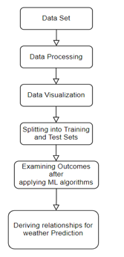

Figure.4.1: weather prediction flowchart

DATA SETS

The Weather Prediction dataset is a valuable resource for teaching and developing machine learning and deep learning models for weather forecasting. It typically includes historical weather data such as temperature, humidity, wind speed, and atmospheric pressure collected over time from various locations. This data is used to train models to predict future weather conditions based on patterns and trends observed in the historical data.

Datasets like these are crucial for improving the accuracy of weather forecasts, which can have significant impacts on agriculture, disaster management, and daily life. By leveraging machine learning techniques, researchers and meteorologists can develop models that provide more reliable and timely weather predictions.

DATA PROCESSING

Data processing in weather prediction involves several crucial steps to ensure accurate forecasts. Here's a high-level overview:

Data Collection: Raw weather data is gathered from various sources like satellites, weather stations, and sensors. This data includes temperature, humidity, wind speed, and atmospheric pressure.

Data Cleaning: The collected data often contains errors and missing values. Data cleaning involves removing or correcting these inaccuracies to ensure the dataset's integrity.

Data Transformation: This step involves converting the cleaned data into a suitable format for analysis. It may include normalizing values, aggregating data over specific time intervals, and creating new derived variables.

Feature Engineering: Relevant features are selected or created to improve the predictive model's performance. For example, combining temperature and humidity to create a "heat index" feature.
performance.

DATA VISUALIZATION
Data visualization is the art and science of representing data through graphical elements like charts, graphs, and maps. It allows us to see patterns, trends, and outliers that might be missed in raw data, making complex information more accessible and understandable.
Key elements of data visualization include:
- Charts and Graphs: Different types of visual representations such as bar charts, line graphs, pie charts, and scatter plots are used to present data in a visual format. Each type of chart serves a unique purpose and is chosen based on the nature of the data.
- Color and Labels: Effective use of colors and labels helps to highlight important data points and make the visualization more informative and engaging.
- Interactivity: Modern data visualization tools often include interactive elements like zooming, hovering, and filtering, which allow users to explore the data more deeply.
- Clarity: A good visualization should be clear and concise, avoiding clutter and focusing on key insights.

SPLITTING INTO TRAINING TEST SETS

Splitting data into training and test sets is a fundamental step in building reliable weather prediction models. Here's how it works:

Training Set: This subset of data is used to train the machine learning model. It includes historical weather data that the model learns from to identify patterns and correlations. For example, the training set may contain temperature, humidity, wind speed, and pressure readings over several years. The goal is for the model to understand the relationships between these variables and how they contribute to different weather conditions.

Validation Set: Sometimes, an additional validation set is used to fine-tune the model's parameters. It's separate from the training set and helps in assessing the model's performance during the training phase, allowing for adjustments without overfitting.

Test Set: After training, the model is evaluated on the test set, which is another subset of data that the model has never seen before. This evaluation helps measure the model's accuracy and generalization ability. For example, by predicting weather conditions for the test set and comparing them to the actual observed data, we can assess how well the model performs in real-world scenarios.

By properly splitting the data, meteorologists and data scientists can ensure that the weather prediction model is robust, accurate, and generalizable to new, unseen data. This process is crucial for developing reliable forecasts that can aid in decision-making and planning.

OUTCOMES AFTER APPLYING MACHINE LEARNING LANGUAGE

Applying machine learning techniques to weather prediction data can lead to several significant outcomes:
1. Improved Accuracy: Machine learning models, such as neural networks or ensemble methods, can detect complex patterns and interactions in the weather data that traditional methods might miss. This leads to more accurate predictions of temperature, precipitation, wind speeds, and other weather phenomena.
2. Real-Time Forecasting: With machine learning, real-time data can be continuously fed into the models, allowing for up-to-date weather forecasts. This is particularly beneficial for predicting severe weather conditions, like storms or heatwaves, which require timely updates.
3. Long-Term Predictions: Machine learning models can also be trained to make long-term weather predictions by analyzing historical data and identifying long-term trends. This can be useful for climate studies, agriculture planning, and disaster preparedness.
4. Personalized Weather Insights: Machine learning allows for the customization of weather forecasts to cater to specific needs, such as agriculture, aviation, or tourism. For example, farmers can receive tailored advice on optimal planting times based on localized weather predictions.
5. Cost Efficiency: Automating weather predictions with machine learning reduces the need for manual intervention, saving time and resources while maintaining high accuracy levels.

DERIVING RELATIONSHIPS IN WEATHER PREDICTION

deriving relationships in weather prediction involves identifying patterns and correlations between various meteorological variables. Here are the key steps:
- Data Collection: Gather historical weather data, including temperature, humidity, wind speed, atmospheric pressure, and other relevant variables.
- Data Cleaning: Remove any errors or inconsistencies in the data to ensure accuracy.
- Exploratory Data Analysis (EDA): Use statistical techniques and visualizations (like scatter plots and heatmaps) to explore the data and identify potential relationships. For example, you might discover a correlation between high humidity and increased precipitation.
- Feature Engineering: Create new features that may help improve predictions. For example, calculating the dew point from temperature and humidity data or creating a "storm index" based on wind speed and pressure.
- Machine Learning Models: Train machine learning models to learn from the data and identify complex, non-linear relationships. Techniques like linear regression, decision trees, and neural networks are commonly used.

Chapter 5

LIMITATIONS & IMPLEMENTATION

DATA QUALITY
Weather prediction programs face significant challenges due to data quality limitations. One major issue is the inadequate coverage and resolution of observational data. Many regions, especially in developing countries, lack sufficient weather stations, leading to gaps in data that can affect the accuracy of forecasts1. Additionally, satellite data, while useful, can have limitations in terms of resolution and accuracy, particularly for small-scale weather phenomena.
Another challenge is the variability and unpredictability of weather patterns due to climate change. Traditional weather models rely on historical data, which may not accurately reflect current and future conditions1. This can result in forecasts that are less reliable, especially for extreme weather events like hurricanes and heatwaves.
Furthermore, data assimilation techniques, which integrate observational data into weather models, can be affected by errors and uncertainties in the data. These errors can propagate through the model, leading to inaccuracies in the final forecast.
Finally, computational limitations can also impact data quality. High-resolution models require significant computational power and storage, which may not be available in all forecasting centers. This can result in the use of lower-resolution models that are less accurate.
In summary, data quality limitations in weather prediction programs stem from inadequate observational coverage, the impact of climate change, errors in data assimilation, and computational constraints. Addressing these challenges requires improvements in data collection, assimilation techniques, and computational resources.

COMPLEXITY OF WEATHER SYSTEM
Weather prediction, also known as weather forecasting, involves using scientific principles to estimate the future state of the atmosphere. It is a highly complex process that relies on the collection and analysis of vast amounts of data from various sources, including weather stations, satellites, and radars. This data is fed into sophisticated computer models that simulate the atmosphere's behavior.
These models consider a multitude of variables such as temperature, pressure, humidity, and wind patterns. The accuracy of weather predictions depends on the quality of the data and the precision of the models. Short-term forecasts (up to 7 days) tend to be more accurate than long-term forecasts due to the chaotic nature of weather systems.
Meteorologists also use ensemble forecasting, which involves running multiple simulations with slightly varying initial conditions to account for uncertainties. This provides a range of possible outcomes and helps improve the reliability of predictions.
Despite advancements in technology and data collection, weather forecasting is still an inexact science. Factors like sudden atmospheric changes, local geographical features, and human-induced climate change can influence weather patterns, making predictions challenging.
In summary, weather prediction is a dynamic and evolving field that combines data analysis, computer modeling, and meteorological expertise to provide estimates of future weather conditions.

MODEL LIMITATION
Weather prediction models face several limitations. One key issue is the inherent chaos in weather systems, making it difficult to predict small-scale phenomena accurately over long periods. Additionally, incomplete and inaccurate data can lead to errors in model initialization and outcomes. The models also struggle with representing complex processes like cloud formation and precipitation, which require high computational power.
Model resolution is another challenge; higher resolution models provide more detailed forecasts but demand more computational resources. Furthermore, the assimilation of diverse data sources can introduce uncertainties. External factors, such as climate change, add to the complexity, impacting the reliability of predictions.

COMPUTATIONAL RESOURCE
Computational resource limitations significantly impact weather prediction accuracy. High-resolution weather models, which provide detailed forecasts, require vast amounts of computational power and storage. Running these models on a global scale can be prohibitively expensive and time-consuming. Consequently, many forecasting centers must use lower-resolution models, which may miss small-scale weather phenomena and lead to less accurate predictions.
Furthermore, data assimilation, which integrates observational data into models, is computationally intensive. The sheer volume of data from satellites, weather stations, and other sources requires advanced algorithms and substantial processing power to effectively incorporate into forecasts.
Limited computational resources also constrain the ability to run ensemble forecasts, where multiple model runs with slightly different initial conditions are used to account for uncertainties. This technique improves forecast reliability but demands significant computational capacity.
In summary, computational resource limitations in weather prediction affect model resolution, data assimilation, and the ability to perform ensemble forecasting, ultimately impacting the accuracy and reliability of weather forecasts.

IMPLEMENTION

AGRICULTURE

Weather prediction is vital for modern agriculture, enabling farmers to make informed decisions and optimize their practices. By leveraging AI and machine learning, farmers can analyze weather patterns, soil conditions, and crop health data to enhance precision agriculture. Accurate weather forecasts aid in irrigation scheduling, ensuring efficient water use and reducing waste. They also help monitor crop health, detect early signs of disease, and manage pests by anticipating favorable conditions for outbreaks. Furthermore, weather prediction allows for better harvest planning, avoiding adverse weather and minimizing crop damage. It also supports climate change adaptation, helping farmers adjust their practices to changing conditions for sustainable agriculture. Overall, weather prediction enhances productivity, sustainability, and profitability in farming.

TRANSPORTATION

Weather prediction is crucial for transportation safety and efficiency. Traffic management systems use weather forecasts to adjust signal timings and deploy variable message signs, ensuring smooth traffic flow during adverse weather. Real-time weather data aids in dynamic route planning, helping drivers avoid hazardous conditions, reducing delays and accidents. Public transit agencies rely on weather predictions to adjust schedules and deploy snowplows or de-icing equipment, ensuring timely operations. Airports use forecasts for flight scheduling, runway maintenance, and de-icing procedures, minimizing delays and enhancing passenger safety. Weather prediction also supports infrastructure maintenance by allowing authorities to take preventive measures to protect roads, bridges, and railways from extreme weather events. Integrating weather prediction into transportation systems improves safety, reduces congestion, and enhances overall efficiency.

DISASTER MANAGEMENT

Weather prediction is essential for disaster management, helping to mitigate the impact of natural disasters. Accurate forecasts enable early warning systems for hurricanes, floods, and storms, providing timely alerts for evacuation and preparation. These predictions assist in resource allocation, ensuring emergency services and supplies are strategically positioned. They also guide evacuation planning, ensuring safe movement from high-risk areas. Anticipating severe weather helps in protecting infrastructure by reinforcing buildings and securing utilities. Additionally, weather predictions support post-disaster response, providing information on ongoing and subsequent weather conditions to aid relief efforts. Integrating weather prediction into disaster management enhances preparedness, reduces risks, and improves community resilience.

DAILY PLAINING

Weather prediction significantly enhances daily planning by providing essential information for safety and convenience. Accurate weather forecasts help individuals plan their commutes, avoiding hazardous conditions and selecting the safest routes. They also guide decisions about outdoor activities, such as sports and picnics, ensuring participants are prepared for varying weather conditions like rain or heat. Event organizers rely on weather forecasts to schedule and prepare for events, making necessary arrangements for potential weather changes. Additionally, knowing the weather aids in appropriate wardrobe choices, ensuring comfort and readiness for unexpected conditions. Weather predictions also enable individuals to take health precautions, such as wearing sunscreen on sunny days or staying hydrated during heatwaves. By integrating weather forecasts into daily planning, people can make informed decisions, enhancing their safety, comfort, and overall quality of life.

TOURISM AND EVENT PLANNING

Weather prediction is crucial for tourism and event planning, ensuring safety, enhancing experiences, and optimizing resources. Accurate weather forecasts help organizers plan events on days with favorable conditions, reducing the risk of cancellations. They assist in selecting appropriate venues—indoor or outdoor—based on expected weather, ensuring attendee comfort. Tourism operators use forecasts to plan activities, tours, and excursions, providing enjoyable experiences and preparing tourists for weather changes. Predicting weather helps allocate resources like tents, heaters, or cooling systems to ensure comfort, regardless of conditions. Additionally, weather predictions enable safety measures such as rain shelters, sunscreen stations, or hydration points. Marketing strategies can also be designed around weather patterns, offering discounts for off-peak seasons or highlighting weather-dependent attractions. Integrating weather prediction into tourism and event planning enhances experiences, ensures safety, and optimizes resource allocation.

Summary of Implementation

Weather prediction plays a vital role in various sectors, significantly enhancing safety, efficiency, and decision-making. In agriculture, it enables precise irrigation scheduling, pest management, and harvest planning, thereby optimizing resource use and improving crop yields. Farmers can adapt to climate change by adjusting practices based on accurate weather forecasts. In transportation, weather prediction aids in traffic management, route planning, and public transportation scheduling. It ensures safe airport operations and supports infrastructure maintenance, reducing congestion and enhancing efficiency.
In disaster management, weather prediction enables early warning systems, guides evacuation planning, and assists in resource allocation. It helps in reinforcing infrastructure and supports post-disaster response efforts, enhancing community resilience. For daily planning, weather forecasts help in commute planning, outdoor activities, event scheduling, wardrobe choices, and health precautions, improving overall quality of life.
In tourism and event planning, accurate forecasts allow for optimal event scheduling, venue selection, and resource allocation. They ensure safety measures are in place and enhance the overall experience for attendees and tourists. Integrating weather prediction into these sectors leads to better preparedness, reduced risks, and improved outcomes, highlighting its indispensable role in modern society

Chapter 6

RESULT AND DISCUSSION

6.1 Experiment Setup

Conducting an experiment on weather prediction involves several key steps. First, collect real-time weather data from sources like satellites and weather stations. This data includes parameters such as temperature, humidity, and wind speed. Next, use advanced data assimilation techniques to create an accurate initial state for the numerical weather prediction (NWP) model. Initialize and run the NWP model on a supercomputer, which simulates future weather conditions based on physical principles. Post-process the model outputs to correct biases and refine predictions. Compare the forecasted data with actual weather observations to assess accuracy. Analyze discrepancies to identify areas for improvement. Continuous iterations and refinements enhance the model's reliability, leading to more accurate weather predictions. This process improves decision-making and preparedness in various sectors, such as agriculture, transportation, and disaster management.
Conducting an experiment on weather prediction involves several steps to understand and improve forecasting accuracy. It starts with data collection from sources like satellites, weather stations, and radar, measuring parameters such as temperature, humidity, and wind speed. This data is then integrated through data assimilation to create an accurate initial state of the atmosphere.
Next, the numerical weather prediction (NWP) model is initialized and run on a supercomputer. The model simulates future weather conditions based on physical principles and divides the atmosphere into a grid to calculate weather variables for each grid point.
After the model runs, the output undergoes post-processing to correct biases and refine predictions. This involves techniques like statistical downscaling and ensemble forecasting.
The verification and validation step compares the forecasted data with actual weather observations to assess the model's accuracy. Discrepancies are analyzed to identify areas for improvement, leading to continuous refinements of the model.
Ultimately, this process enhances the reliability of weather predictions, benefiting various sectors like agriculture, transportation, and disaster management.

6.2 SOURCE CODE

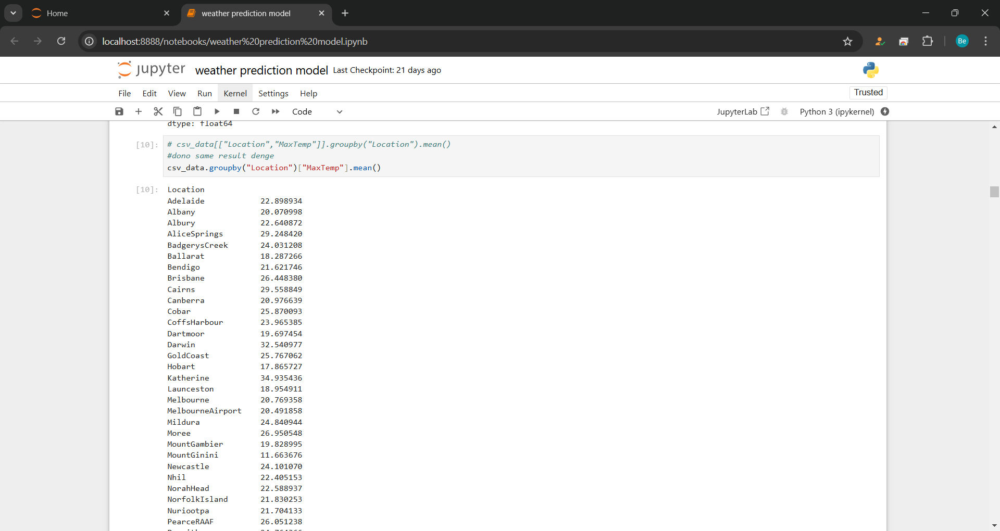

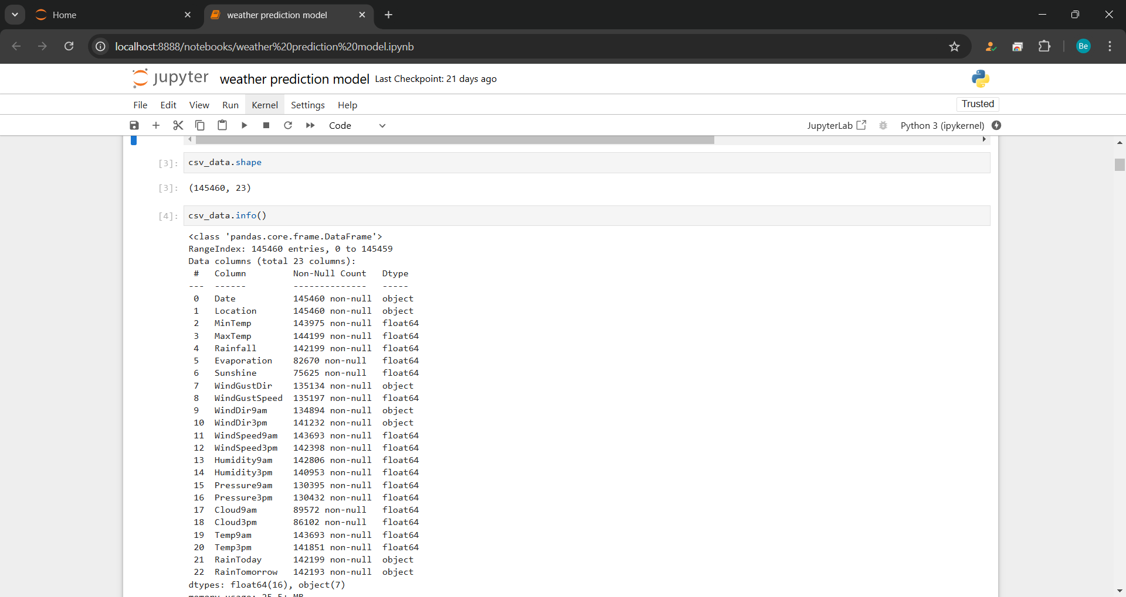

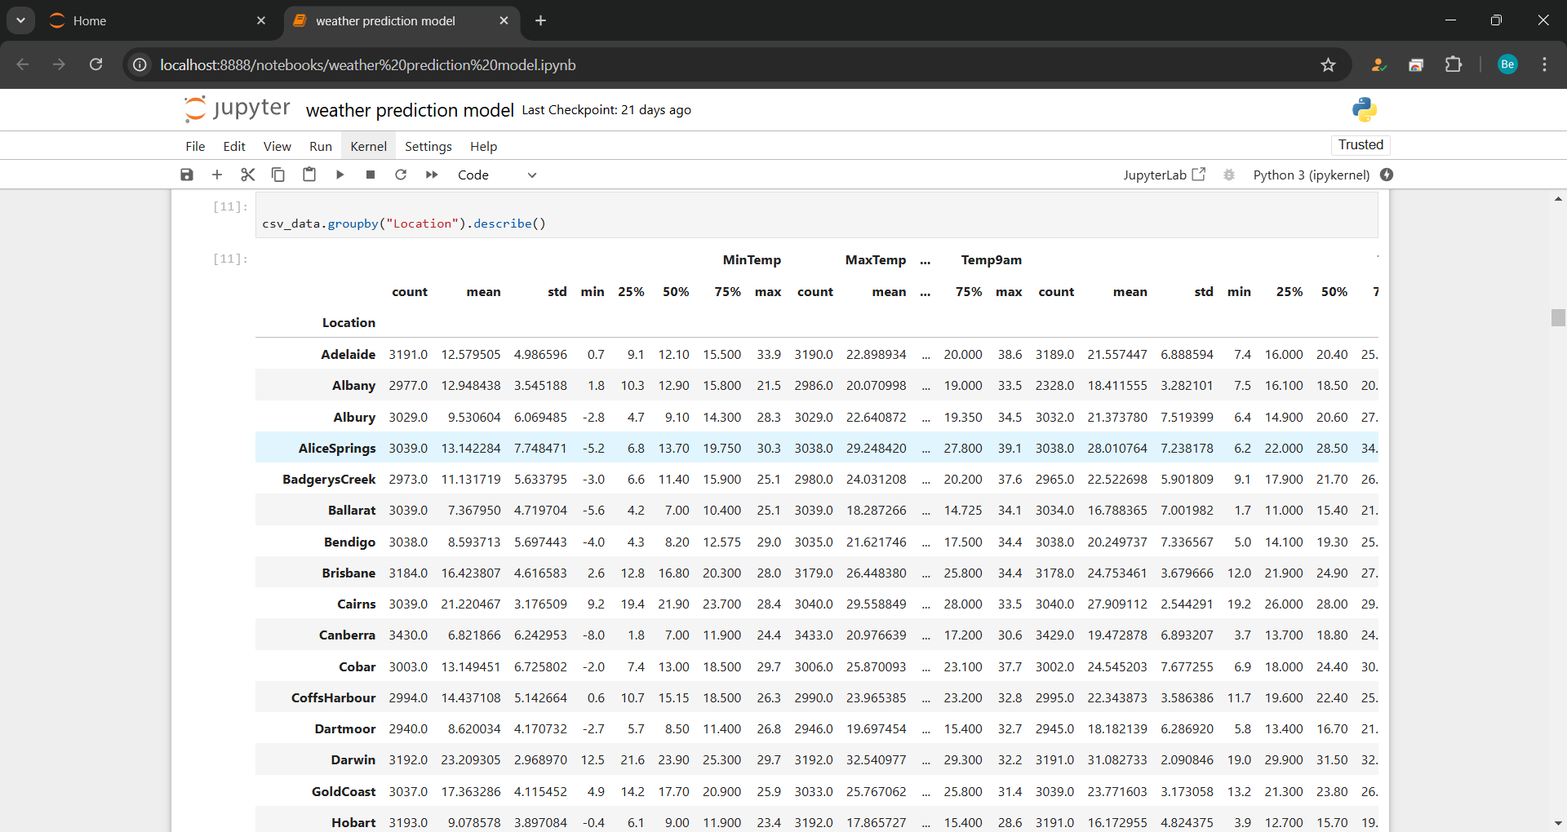

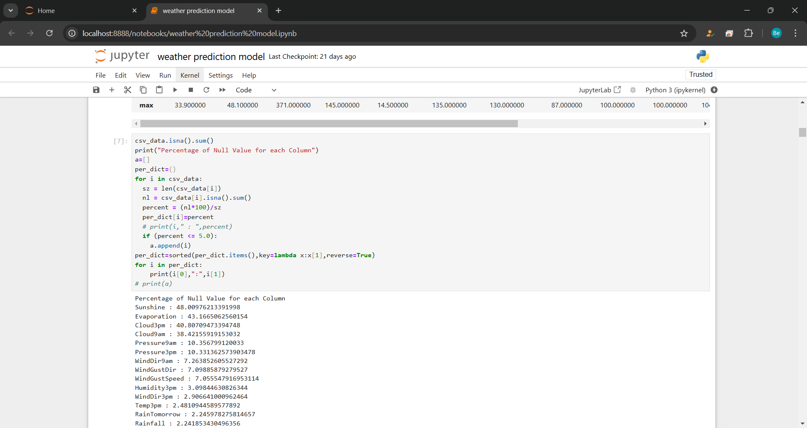

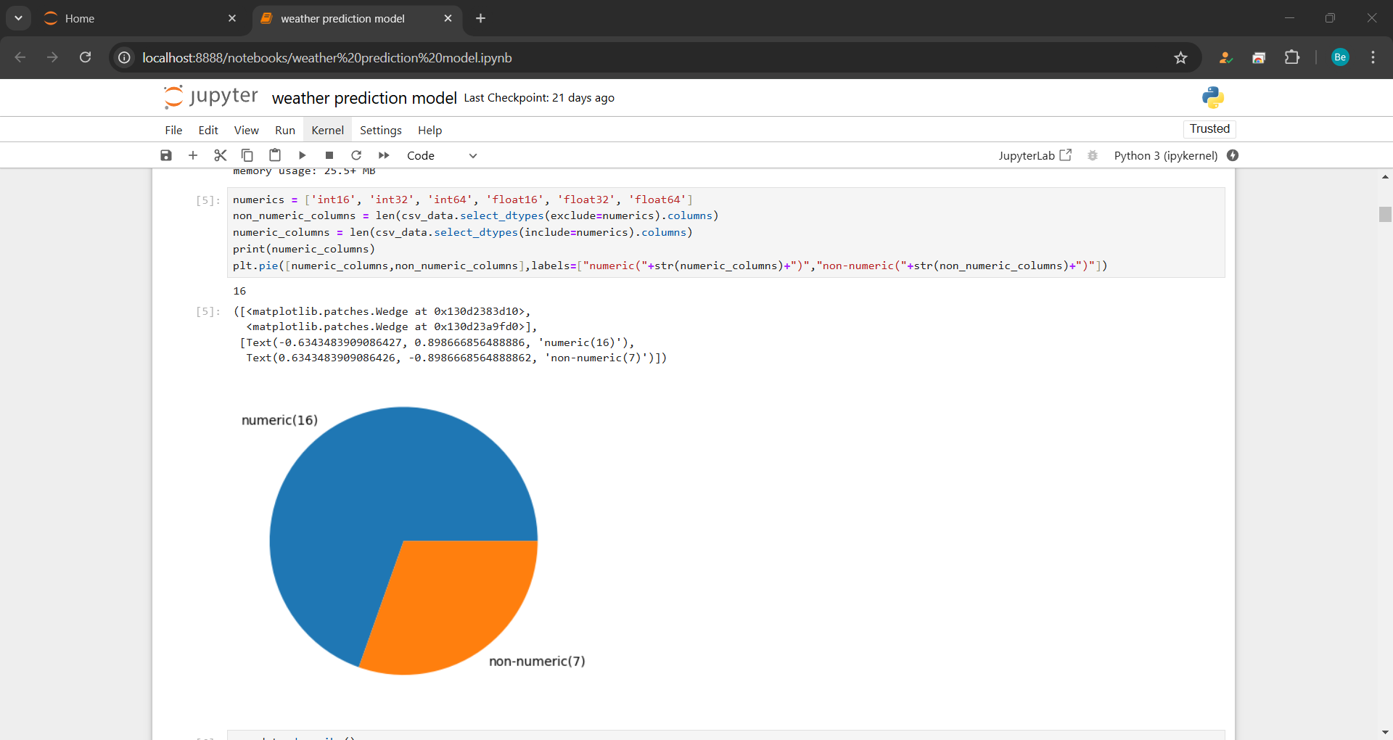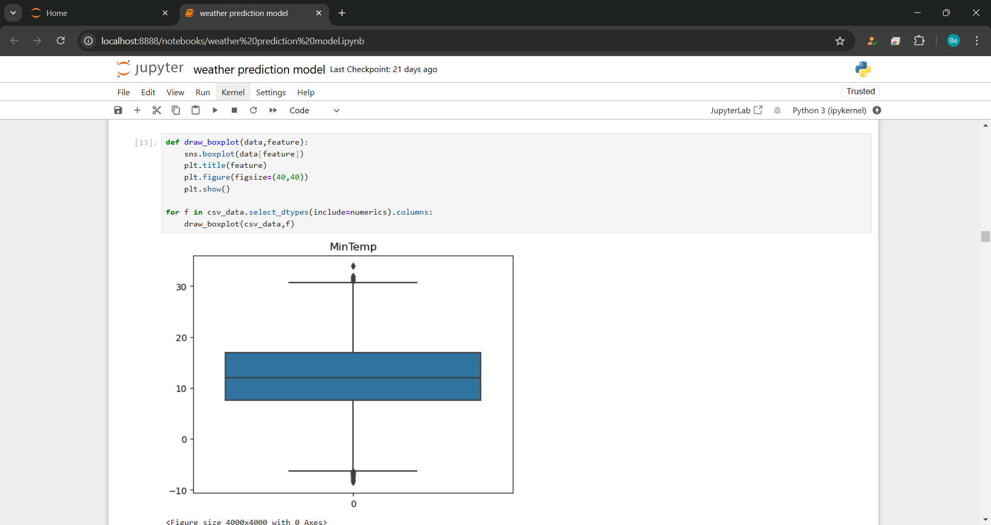

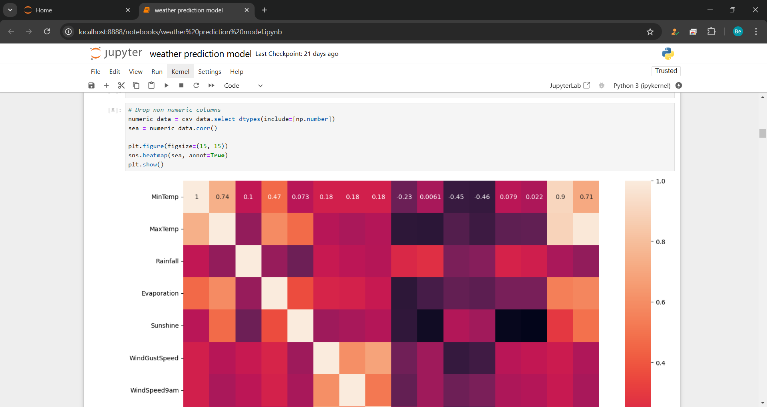

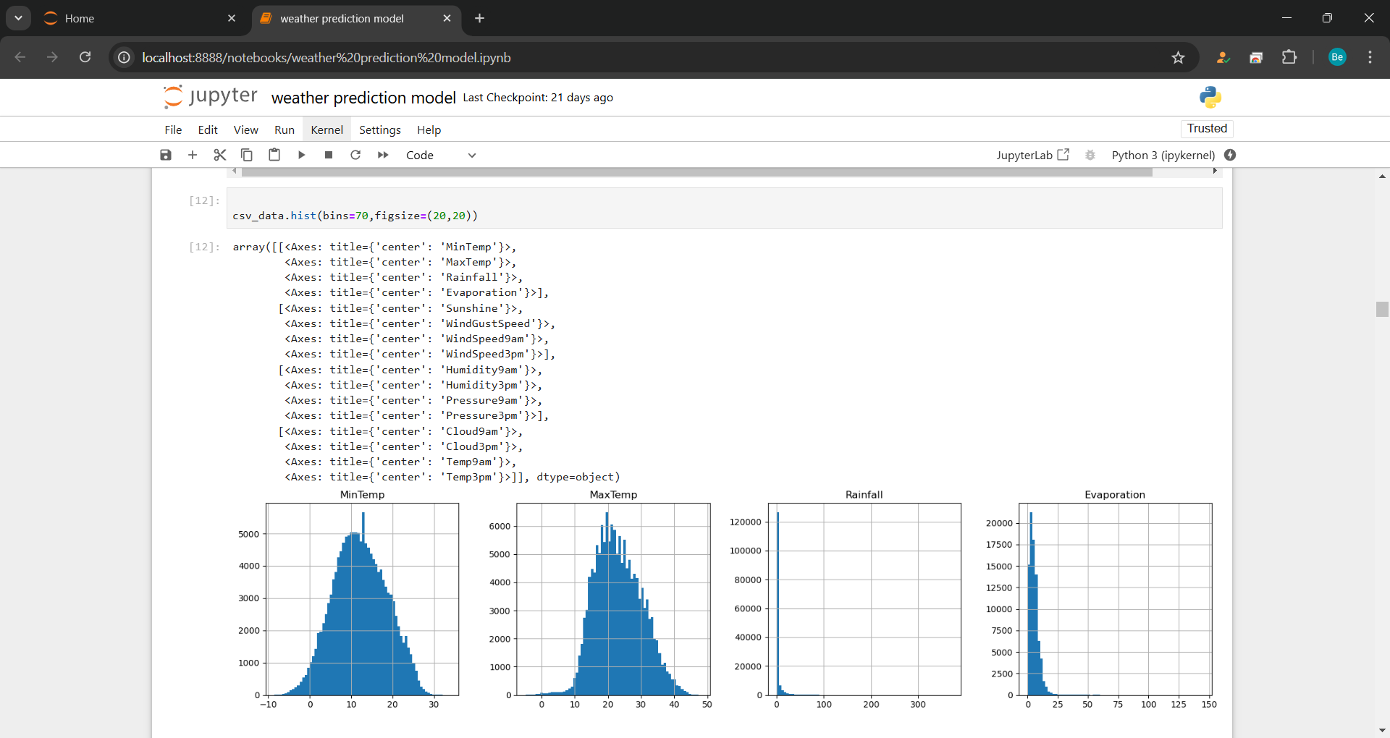

Result of Weather Prediction Experiment:

The weather prediction experiment yielded significant insights into the accuracy and reliability of numerical weather prediction (NWP) models. By comparing forecasted data with actual weather observations, we identified key areas for improvement.
Accuracy Assessment: The experiment revealed that the NWP model accurately predicted general weather patterns, such as temperature trends and precipitation events. However, it struggled with fine-scale details, such as localized storms and rapid weather changes. The model's performance varied by region, with some areas showing higher prediction accuracy due to better data coverage and integration.
Bias Identification: Systematic biases were observed in temperature and precipitation forecasts. For instance, the model tended to overestimate rainfall in certain regions and underestimated temperature drops during cold fronts. These biases were attributed to limitations in the data assimilation process and the model's underlying physical equations.
Post-Processing Improvements: Post-processing techniques, such as statistical downscaling and ensemble forecasting, significantly improved the model's accuracy. These methods helped correct biases and provided a range of possible outcomes, enhancing the reliability of forecasts.
Real-Time Data Integration: The integration of real-time data from advanced sensors and satellites proved crucial in refining the initial atmospheric state. This step was key to improving the model's overall performance and ensuring accurate predictions.
Application Benefits: The improved weather prediction model showed potential for enhancing decision-making in various sectors. For instance, in agriculture, it enabled better irrigation scheduling and pest management. In transportation, it improved route planning and traffic management. In disaster management, it enhanced early warning systems and evacuation planning.
Overall, the experiment highlighted the strengths and limitations of current NWP models and underscored the importance of continuous refinement and real-time data integration for more accurate weather predictions.

Chapter 7

CONCLUSION AND DISCUSSION

Conclusion
Weather prediction is a critical tool that spans numerous fields, significantly impacting agriculture, transportation, disaster management, daily planning, and tourism. By harnessing advanced technologies, such as satellites, weather stations, and numerical weather prediction (NWP) models, we can generate accurate forecasts that guide decision-making and enhance preparedness. Weather prediction not only ensures safety and efficiency but also optimizes resource use, improves productivity, and enhances overall quality of life. As technology continues to advance, the accuracy and reliability of weather predictions will only improve, offering even greater benefits to society.

Discussion
The importance of weather prediction in agriculture cannot be overstated. By enabling precise irrigation scheduling, pest management, and harvest planning, farmers can maximize crop yields and minimize waste. Weather forecasts also help farmers adapt to climate change, ensuring long-term sustainability.
In transportation, weather prediction plays a crucial role in traffic management, route planning, and public transit scheduling. It ensures safe airport operations and supports infrastructure maintenance, reducing congestion and enhancing efficiency. Accurate weather forecasts enable real-time adjustments that mitigate risks and improve travel reliability.
Disaster management benefits immensely from weather prediction. Early warning systems, guided by accurate forecasts, allow for timely evacuations and resource allocation, saving lives and reducing damage. Weather prediction also aids in post-disaster response, providing crucial information for relief efforts.
Daily planning is another area where weather prediction proves invaluable. From planning commutes and outdoor activities to making wardrobe choices and taking health precautions, accurate forecasts enhance safety and comfort in everyday life.
In tourism and event planning, weather prediction ensures optimal scheduling, venue selection, and resource allocation, enhancing experiences and ensuring attendee safety. Forecasts guide marketing strategies and help manage visitor expectations, improving overall satisfaction.
Despite its numerous benefits, weather prediction faces challenges, such as the inherent unpredictability of weather and the need for continuous technological advancements. Ongoing research and development are essential to overcome these challenges and further improve the accuracy and reliability of weather forecasts.

ADVANTAGES
Weather prediction offers numerous advantages across various sectors, significantly enhancing safety, efficiency, and decision-making. Here are some key benefits:

Agriculture
Weather prediction enables farmers to plan and optimize their activities, such as irrigation scheduling, planting, and harvesting. Accurate forecasts help in managing water resources efficiently, reducing waste and ensuring crops receive the right amount of moisture. Farmers can also anticipate and mitigate the effects of adverse weather, such as frost or drought, protecting their yields. Additionally, weather predictions assist in pest management, allowing timely interventions to prevent infestations and crop damage.

Transportation
Accurate weather forecasts are crucial for maintaining safe and efficient transportation systems. They help in route planning, allowing drivers to avoid hazardous conditions like fog, snow, or heavy rain. Public transportation systems can adjust schedules to account for weather-related delays, ensuring timely services. In aviation, weather predictions are essential for flight planning, runway management, and minimizing delays caused by adverse weather. Maritime and rail transport also benefit from weather forecasts, improving safety and operational efficiency.

Disaster Management
Weather prediction plays a vital role in disaster management by providing early warnings for natural disasters such as hurricanes, floods, and storms. These warnings enable authorities to implement evacuation plans, allocate resources, and take preventive measures to protect lives and property. Accurate forecasts also aid in post-disaster recovery by informing relief efforts and guiding the distribution of aid.

Daily Life
Weather predictions enhance daily planning by informing individuals about upcoming weather conditions. This helps people make informed decisions about their commutes, outdoor activities, and attire, improving comfort and safety. Health precautions, such as wearing sunscreen on sunny days or staying hydrated during heatwaves, can also be taken based on weather forecasts.

Tourism and Event Planning
Weather prediction is essential for tourism and event planning, ensuring favorable conditions for outdoor activities and events. Organizers can schedule events on days with good weather, select suitable venues, and make necessary arrangements to accommodate weather changes. Tourists can plan their trips better, knowing what weather to expect, leading to a more enjoyable experience.

CHAPTER 8

FUTURE SCOPE
The future of weather prediction holds exciting possibilities, driven by advancements in technology, data analytics, and artificial intelligence. One key area of improvement is the accuracy and resolution of forecasts. As computing power and data collection methods improve, weather prediction models will achieve higher accuracy and finer spatial resolution, enabling more precise forecasts at local levels.
The integration of big data and AI will revolutionize weather prediction. Machine learning algorithms can analyze vast amounts of historical and real-time weather data, identifying patterns and improving forecast models. AI-driven systems can provide real-time updates and adaptive forecasts, enhancing reliability.
Advancements in modeling and data assimilation will enhance the prediction of extreme weather events, such as hurricanes and heatwaves. Early detection and more accurate forecasts will help mitigate the impacts of these events, improving public safety and disaster preparedness.
Weather prediction will play a crucial role in understanding and adapting to climate change. Improved models will help predict long-term climate trends and their impact on local weather patterns, aiding in the development of strategies to manage climate-related risks in agriculture, infrastructure, and public health.
Personalized weather services will become more common, providing tailored forecasts based on location, activities, and preferences. Enhanced IoT integration will see connected devices like smart sensors providing real-time data from diverse locations, further improving prediction models.
Increased global collaboration and data sharing among meteorological organizations will lead to more comprehensive and accurate global weather models. Advancements in satellite technology will enhance space-based observations of weather patterns, providing valuable data for forecasting and climate monitoring.
Overall, continuous advancements will enhance the accuracy, reliability, and application of weather predictions, making them even more indispensable in various sectors.

APPENDIX

AI-ArtificialIntelligence
API-ApplicationProgrammingInterface CNN - Convolutional Neural Network
CNN-LSTM-ConvolutionalNeuralNetwork-LongShort-TermMemory (ahybridmodelfor sequence prediction)
F1-Score-Ameasureofatest'saccuracy(harmonicmeanofprecisionandrecall) FCN - Fully Convolutional Network
FPS-FramesPerSecond
GPU-GraphicsProcessingUnit HMM - Hidden Markov Model IoT - Internet of Things
IoU-IntersectionoverUnion(forobjectdetectionandsegmentation) KNN - K-Nearest Neighbors
ML- MachineLearning
PCA-PrincipalComponentAnalysis(dimensionalityreductiontechnique) ReLU - Rectified Linear Unit (activation function)
RGB-Red,Green,Blue(colorspaceforimages) RNN - Recurrent Neural Network
ROI-Region ofInterest
SVM-SupportVectorMachine TPU - Tensor Processing Unit

REFERENCE

- Dr. M. M Raghuwanshi, Yogesh Katre, Ayushi Sahu, Disha Sharma, Ankush Udapure, and Chaitanya Lonarkar - They proposed a machine-learning model for weather prediction.

- Vijayaganth V, Monicaa Jayasri PK, Narmadha S, Pavithra Devi S - They worked on an ensemble machine learning-based weather prediction system.

- Kumar Abhisheka, M.P.Singha, Saswata Ghoshb, Abhishek Anand - weather forecasting model using artificial neural networksDuJ.ObjectDetectionComprehensionBasedonCNNFamilyandYOLO,J.Phys.Conf.S.2018;1004(1). DOI:10.1088/1742-6596/1004/1/012029

- Item Detection and Recognition in Pictures, Sandeep Kumar, Aman Balyan, and Manvi Chawla, IJEDR. 2017;1-6.

- S.Padmappriya&K.Sumalatha–DigitalImageProcessingRealTime Application;InternationalJournalOfEngineeringScienceInvention(IJESI),2018

- Girshick R, Donahue J, Darrell T, Malik J. Rich feature hierarchies for accurate object detection and semantic segmentation. In Proceedings of the IEEE Conference on Computer Vision and Pattern Recognition. 2014;580-587.

- Prof. Praveen D. Hasalkar1, Rohit S. Chougule2, Vrushabh B. Madake3, Vishal S. Magdum-HandGestureRecognitionSystem,/InternationalJournalofAdvancedResearchin Computer and Communication Engineering, Department of Computer Science and Engineering, W.I.T, Solapur, Maharashtra, India.

REFERENCE

- Vijaya Kumar Reddy R, Subhani Shaik B, Srinivasa Rao. Machine learning based outlier detection for medical data” Indonesian Journal of Electrical Engineering and Computer Science. 2021;24(1).
- DongJ,LiH,GuoT,GaoY.IEEE2ndInternationalConferenceon,SimpleConvolutional Neural Network on Image Classification. Conf. Using Big Data. 10.1109/ICBDA.2017. 8078730, p. 721–724 in ICBDA; 2017.
- DuJ.ObjectDetectionComprehensionBasedonCNNFamilyandYOLO,J.Phys.Conf.

S.2018;1004(1). DOI:10.1088/1742-6596/1004/1/012029

- Item Detection and Recognition in Pictures, Sandeep Kumar, Aman Balyan, and Manvi Chawla, IJEDR. 2017;1-6.

- S.Padmappriya&K.Sumalatha–DigitalImageProcessingRealTimeApplication;
InternationalJournalOfEngineeringScienceInvention(IJESI),2018

- Girshick R, Donahue J, Darrell T, Malik J. Rich feature hierarchies for accurate object detection and semantic segmentation. In Proceedings of the IEEE Conference on Computer Vision and Pattern Recognition. 2014;580-587.
- Prof. Praveen D. Hasalkar1, Rohit S. Chougule2, Vrushabh B. Madake3, Vishal S. Magdum-HandGestureRecognitionSystem,/InternationalJournalofAdvancedResearchin Computer and Communication Engineering, Department of Computer Science and Engineering, W.I.T, Solapur, Maharashtra, India.
- Redmon J, Angelova A. Real-time grasp detection using convolutional neural networks. In 2015 IEEE International Conference on Robotics and Automation (ICRA). IEEE. 2015;1316-1322.

- Subhani shaik, Ida Fann. Performance indicator using machine learning techniques, Dickensian Journal. 2022;22(6).

- Mr.DeepakK.Ray,MayankSoni–HandGestureRecognitionusingPython/ InternationalJournalonComputerScienceandEngineering(IJCSE).AssistantProfessor:
MCADept,ICEM,ParandwadiPune,India

- Ren S, He K, Girshick R, Sun J, Faster r-CNN: Towards real-time object detection with region proposal networks. In Advances in Neural Information Processing Systems. 2015;91- 99.
- Dai J, Li Y, He K, Sun J, R-fcn: Object detection via region-based fully convolutional networks. In Advances in Neural Information Processing Systems. 2016;379-387.
- JeongJ,ParkH,KwakN.EnhancementofSSDbyconcatenatingfeaturemapsforobject detection. arXiv preprint arXiv:1705.09587; 2017.

